Highrise Trickshot
Category: Web | Difficulty: Easy-Medium

Description
Trickshot-only lobby on Highrise. The host will give you the flag if you hit a trickshot worth 10,000,000,000 points. Good luck, MLG pro.
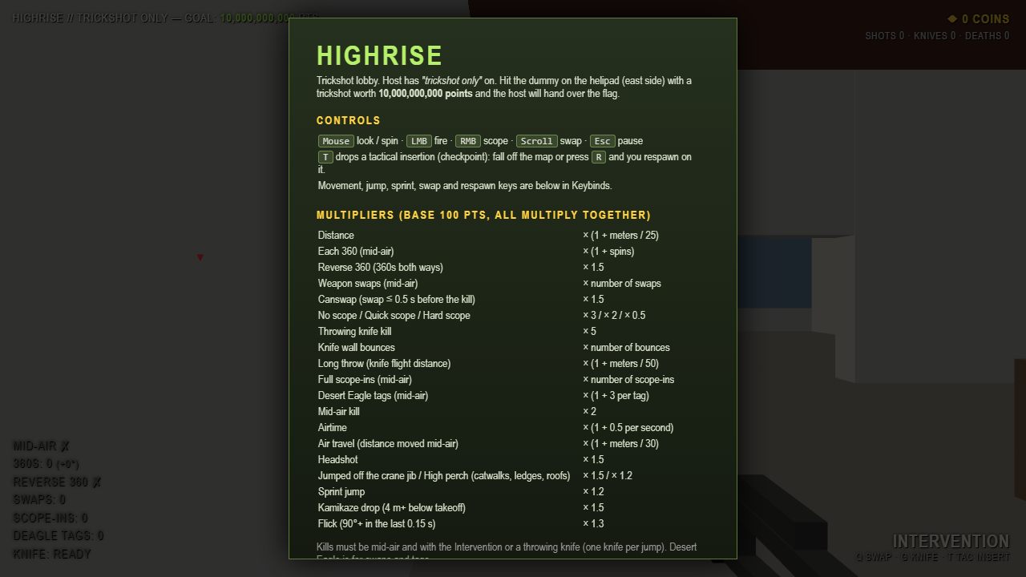
The Highrise trickshot lobby — goal: 10 billion points

Files
One hosted Docker container, built from challenge/. From that folder:
cd challenge
docker compose up --build -d # serves http://localhost:8081
The flag is set by the FLAG env var (see challenge/docker-compose.yml); redeem codes are configured there too. Players need only a browser. The client is challenge/static/game.js (+ challenge/static/map.js, challenge/static/index.html); the authoritative server/anti-cheat is challenge/app.py. Author writeup: organizer/SOLUTION.md.

Hint(s)
- The client never sends a score — the server re-simulates your whole jump from a frame-by-frame input log and computes every multiplier itself. So editing the score, REQUIRED_SCORE, or the captured packet gets you nowhere.
- Look at /api/takeoff: it sends your CONFIG object, and the server replays the trick with whatever physics you committed (within loose ranges). What happens if you change the physics before you jump?
- The perk shop names the exact knobs: lower GRAVITY (more hang time → more spins), SWAP_COOLDOWN/SWAP_TIME → 0 (swap every frame), NOSCOPE_SPREAD → 0 (noscopes land dead-on). Edit them in game.js via DevTools Overrides, then actually pull off the trick.

Walkthrough
The anti-cheat is only "as strong as the settings you commit." /api/takeoff trusts the client-supplied CONFIG, and the server re-simulates the trick with it — so editing the physics in the client changes what the server considers possible. The score grows roughly with airtime² × spins × swaps, and two multipliers (360s and swaps) have no cap.
- Recon. Play a round and watch the Network tab: POST /api/session (one-time ticket + dummy spawn), POST /api/takeoff (your CONFIG + starting state, committed on jump), POST /api/trickshot (the frame-by-frame input log). The server replays the log, re-checks the final shot really hits its dummy, checks airtime vs wall-clock, burns the ticket, and computes the score. So replaying fails (ticket used), editing stats is impossible (none are sent), and editing the final packet can't change the already-committed settings.
- The bug / edit the physics. In game.js, CONFIG holds the physics the client sends at takeoff. Edit four values via DevTools → Sources → Overrides (right-click game.js → Override content, Ctrl+S, reload) — the exact knobs the perk shop hints at:
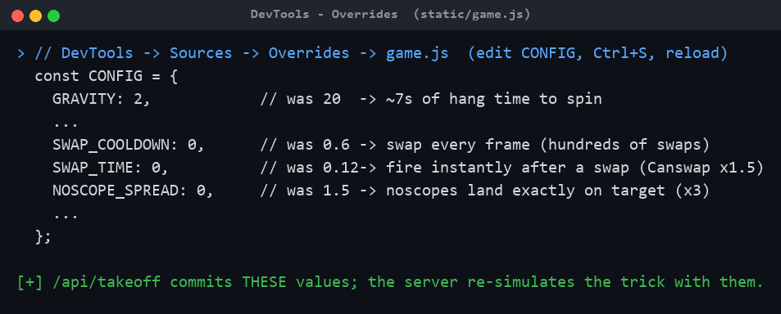
DevTools Overrides: the four CONFIG edits
- GRAVITY: 20 → 2 — seconds of hang time instead of ~0.7s, so far more spins and a bigger airtime multiplier.
- SWAP_COOLDOWN: 0.6 → 0 and SWAP_TIME: 0.12 → 0 — swap weapons every frame (each adds ×0.5) and fire instantly after a swap (Canswap ×1.5).
- NOSCOPE_SPREAD: 1.5 → 0 — noscopes land exactly where you aim (×3).
(MAX_TURN_RATE already defaults to the server cap of 1e7 °/s, so there's effectively no spin-speed limit.)
- Pull off the trick. With the edits committed at takeoff, jump off the deck and — while airborne — spin as fast as the game accepts and spam weapon swaps; the HUD shows the 360s and Swaps counters exploding. (The MOMGETTHECAMERA redeem code + the Aimbot perk make the final shot trivial.)
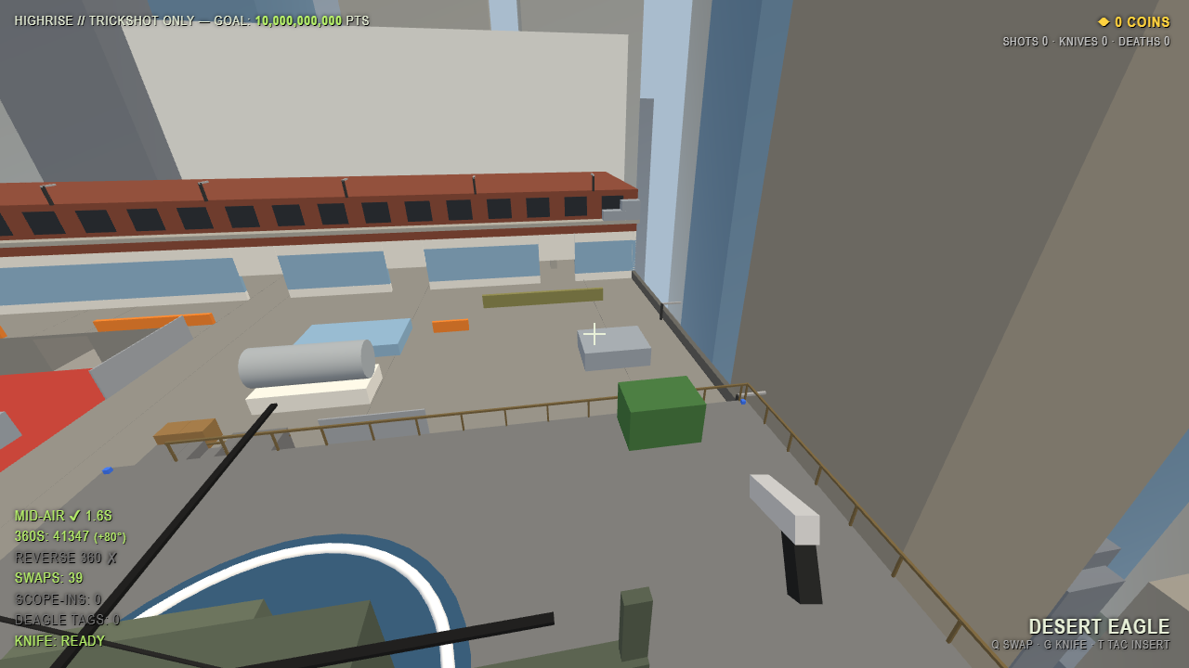
Mid-air: thousands of 360s racking up
- Land the shot and collect the flag. Before touching down, fire the Intervention (noscope) at the dummy for a mid-air headshot. The server re-simulates the committed trick, the score clears 10,000,000,000, and the host hands over the flag:
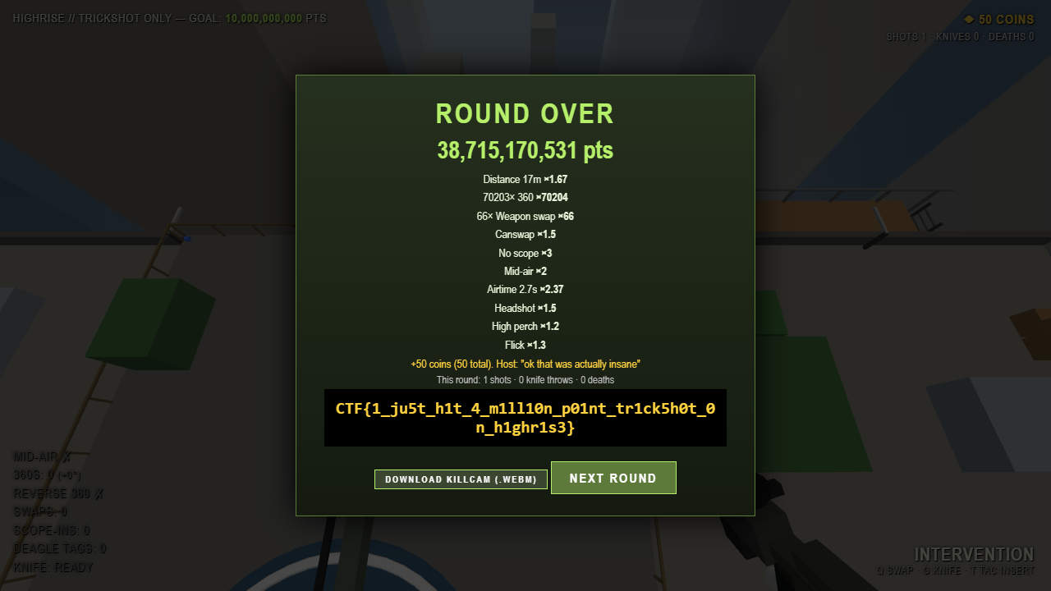
Round over: 38.7B points and the flag
This walkthrough was produced by driving the *real* client through its genuine input-recording path (the same automation the author used in their headless test): only the four CONFIG values were changed, and the server independently re-simulated the recorded spins/swaps/shot and returned the flag — a verified solve (final score 38,715,170,531: 70,203× 360 · 66× swap · Canswap · No scope ×3 · Mid-air ×2 · Headshot · High perch · Flick).

Flag
CTF{1_ju5t_h1t_4_m1ll10n_p01nt_tr1ck5h0t_0n_h1ghr1s3}

